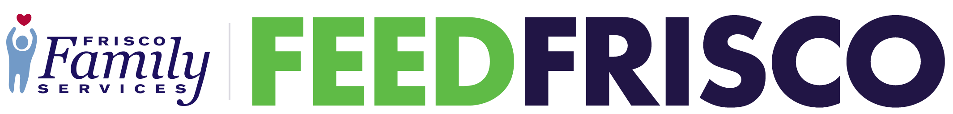

Your Company or Group Name or Logo here
is helping prevent hunger by collecting donations for Frisco Family Services Food Pantry

Please bring some of these most critically needed Food Pantry items:

.....List Item/s here.....

On these dates:

.......List dates of Drive here.....

Donations may be left:

.....Location.....

Frisco Family Services helps members of our Frisco and Frisco ISD communities who are facing hunger, homelessness and other urgent needs improve their quality of life and achieve self-sufficiency.
FriscoFamilyServices.org

